(Mr. Tenkey's Tips #308) www.mrtenkey.com

May 13, 2020

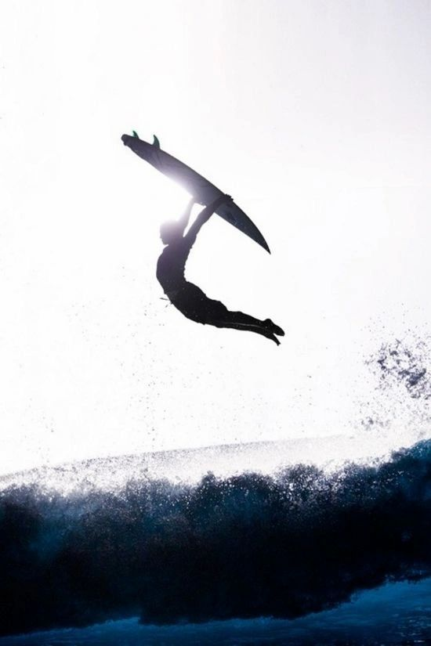

Dear Management: Yeah! For record breaking production months!  
  
Yeah! So is EVERYONE ELSE!  
  
And hey, that is ALL GOOD!  
  
But you know what's better?  
  
Being above the natural curve of the industry.  
  
So while everyone else paddles their surfboards... up and down the waves...  
  
Find your charisma, uniqueness, nerve and talent!!!  
  
To rise up...  
  
And surf ABOVE the waves!