(Mr. Tenkey's Tips #309) www.mrtenkey.com

May 14, 2020

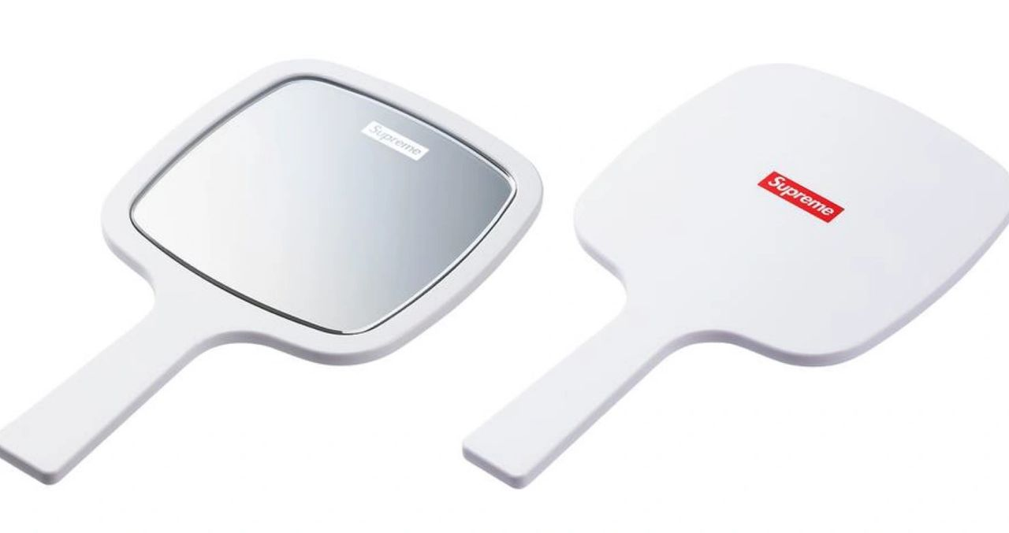

Dear Management: In taking stock of one's professional life...  
  
How do you feel about the your contributions to an assignment, a team project, your department, your branch, your division, or your company for that matter???  
  
Does the train move forward on the track... in SPITE of you... or BECAUSE of your contributions?  
  
REVEL in that realization... or RE-EVALUATE things because of it.  
  
A mirror has two sides...  
  
It's your choice, at which side you choose to gaze.