(Mr. Tenkey's Tips #314) www.mrtenkey.com

May 21, 2020

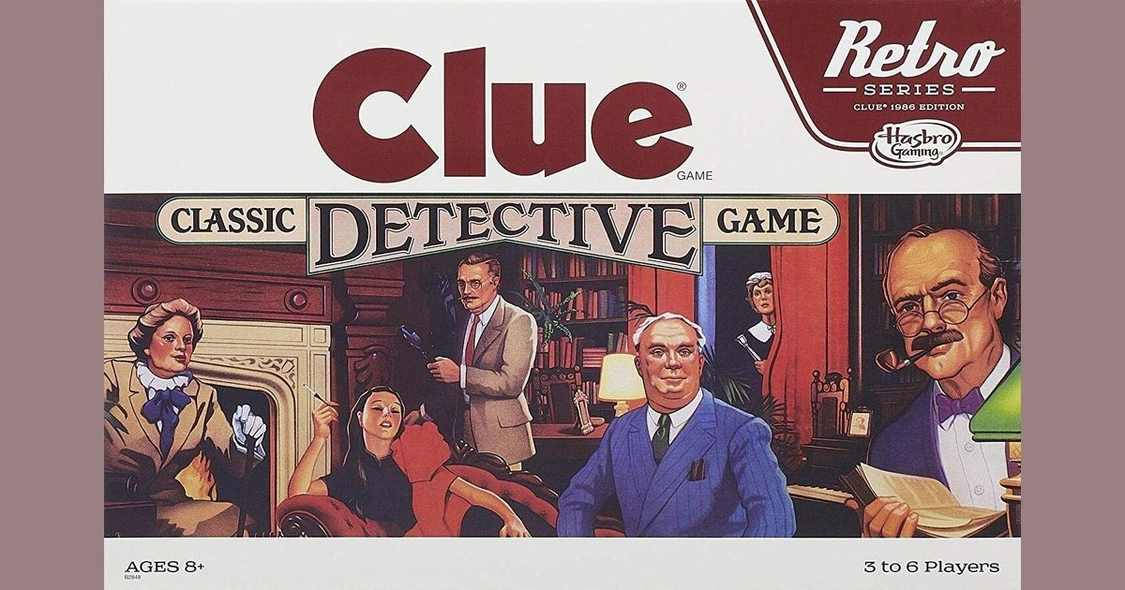

Dear Management: For those of you out there, that are quick to JUDGE... or... are an expert in the game of BLAME.  
  
I heed a warning...  
  
Facts are like zombies... they can't be buried and forgotten.  
  
Oh yes... you can scare them with fire, take them out at the knees, stab them in the back and/or run them over with a bus...  
  
But facts... just keep coming back.  
  
You're only defense???  
  
Time to change!!!  
  
Your occupation from Judge to Juror...  
  
Your game from Blame to Detective.  
  
As in Clue...  
  
(catch one today!)