(Mr. Tenkey's Tips #316) www.mrtenkey.com

May 26, 2020

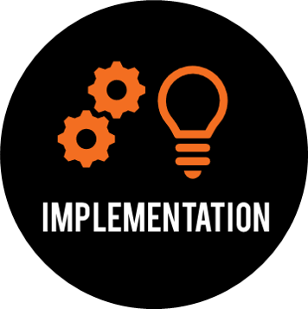

Dear Management: Ever try a "soft" implementation... of a new software you're about to "go live" with?  
  
What is a soft implementation?  
  
Well, in my case it's something I am calling the initialization of a new accounting software (Loanvision)... we recently purchased.  
  
Everything has been going well with the setup... even through all this Covid crap... but progress HAS been hindered.  
  
We had initially set the go live date as May 1st.  
  
BUT, as that date crept up (+ Covid)... we stopped... and re'evaluated...  
  
We switched from thinking... "get it working asap" to "let's do what works best"...  
  
AND THAT has made all the difference.  
  
We pushed the date to June 1 and did a "soft" implementation on May 1st, instead.  
  
Yep, it allowed us an additional month of training, running through scenarios, and shadowing processes in both systems.  
  
AND BEST of all, the pressure was off!!!  
  
The system was fully functional, our people could pace their initialization into the new system and gain confidence.  
  
And now, we are READY!  
  
So JUNE 1st!... come and get us!