(Mr. Tenkey's Tips # 323) www.mrtenkey.com

June 4, 2020

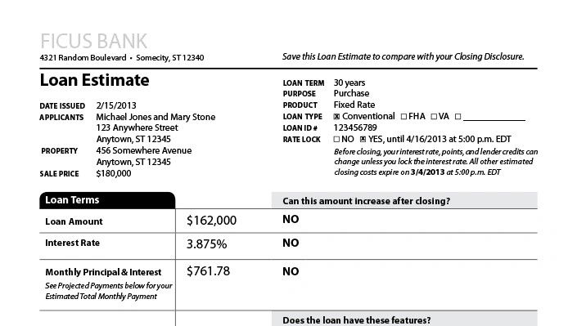

Dear Management: A solid offer was just handed to your borrower...  
  
One that was made with a FULL understanding of your company's "value added" strategy, your company's overhead needs and just as important, your LO's desired compensation.  
  
And the borrower pushes back.  
  
So you??? Give in???  
  
Whaaaaa?  
  
Are you just backing off as far as you have to... to "keep" the deal?  
  
So that means you're just jacking up prices for the dumb borrowers, who won't push back... only to lower when pushed?  
  
Or are you not worth the value presented on your offer?  
  
Then you my friend are lost...  
  
On matching your pricing... to your needs.  
  
So... get to work.