(Mr. Tenkey's Tips # 331) www.mrtenkey.com

June 16, 2020

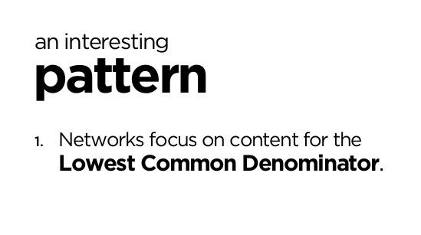

Dear Management: An interesting pattern indeed...  
  
And often a similar pattern, to that found in setting up policies and procedures for your company.  
  
If you design them for the lowest common denominator of employee in mind...  
  
Then those are the employees that you will end up with.  
  
Moral:  
Provide more.  
Request more.  
Get more.