(Mr. Tenkey's Tips # 337) www.mrtenkey.com

June 24, 2020

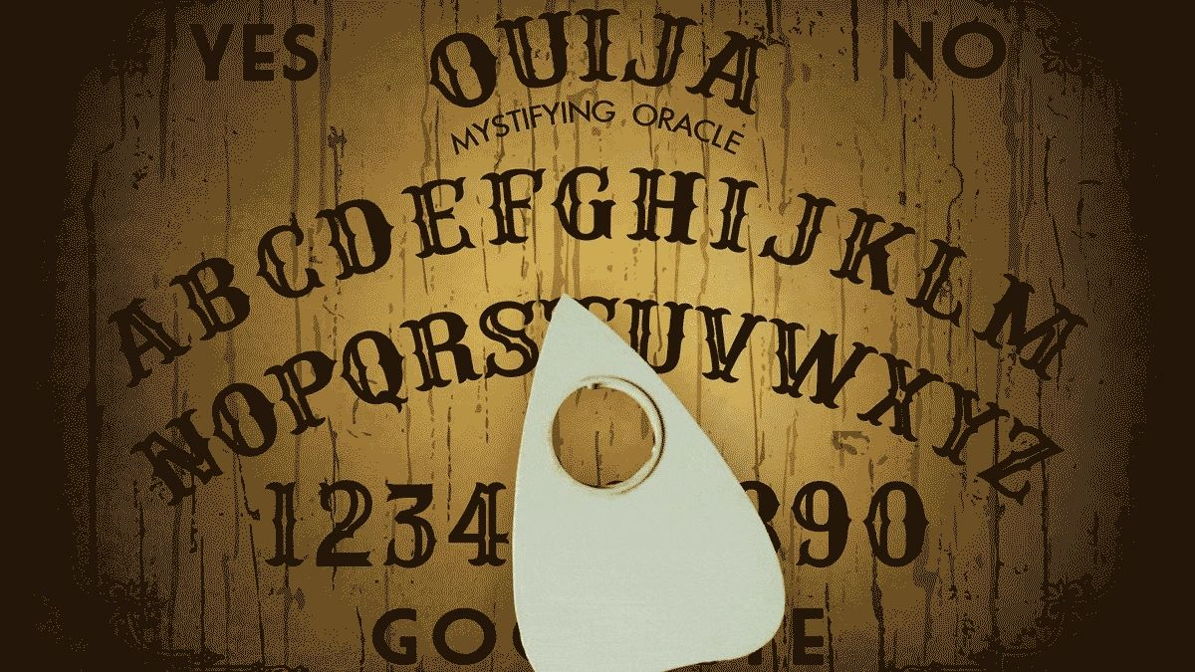

Dear Management: Simplification!!!  
  
Is a double-edged sword... when it comes to implementing and maintaining one's operational procedures.  
  
The first cuts are like but-tah!... cutting waste and inefficiency... left and right!  
  
But then that second cut... OVER-SIMPLIFYING... most notably in training of the "why" behind the process at hand.  
  
Also known as the "dumb it down so anyone can do it" approach.  
  
Resulting in an over-reliance of institutional knowledge and decision making... in the hands of only a few key people.  
  
BUT  
  
What happens??? if that proverbial bus hits one of them? Or they simply leave.  
  
How does that knowledge get passed down then?  
  
By Ouija board?  
  
Please remember my warning.  
  
As those people you trained "simply"... won't be able to remember things, they never were trained to know in the first place.  
  
My couple pennies.