(Mr. Tenkey's Tips # 347) www.mrtenkey.com

July 8, 2020

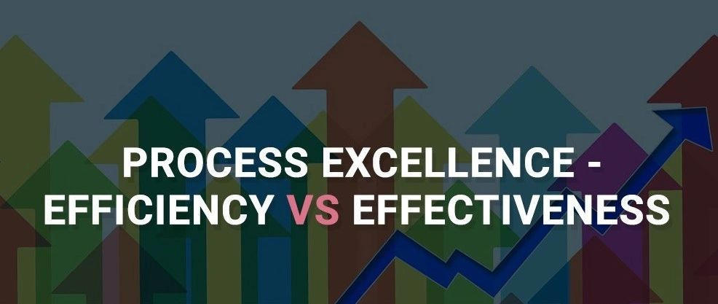

Dear Management: Two scenarios for you...  
  
1) An LO, using a customized excel spreadsheet to track client contact and status info.  
  
2) An LO, using company CRM software, to do the same thing.  
  
The question at hand... which is more efficient?  
  
And of course, many of you will lean toward the CRM software... because, why not. Fancy database software always wins over a simple spreadsheet, right???  
  
What if I also told you that both LO's are doing 20 million monthly? (with the same # of support staff)...  
  
Cat got your tongue?  
  
Let me help you out... because with efficiency... there has to also be effectiveness. So if the CRM is not customizable to the LO's way of conducting THEIR business... THEIR way... then all that is created, is new inefficiencies.  
  
And to restate a prior disclaimer... I AM NOT AGAINST NEW TECHNOLOGY... I am only against new tech that promises efficiency, only to skirt a burden to other areas.  
  
So MORAL - Improved technology is a "win!", ONLY if it improves the NET efficiency of the NET effectiveness of a process or procedure.