(Mr. Tenkey's Tips # 350) www.mrtenkey.com

July 13, 2020

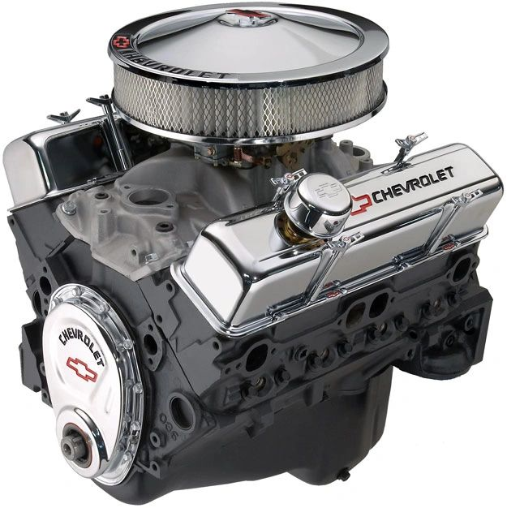

Dear Management: The # of this post is special to me... It reminds me of everything I love about classic cars... and nothing is more classic than a 350 Chevy engine.  
  
What can I say... classic, powerful, dependable, durable, timeless perfection on wheels...  
  
But I know... some of you out there aren't impressed.  
  
You gaze in other "flashier" directions, at such things like Ferrari's Testarossa V12.  
  
But why? So you can go 150 mph from one stop light, to another? All flash, high maintenance and NOTHING NEW since the days when Don Johnson was cool.  
  
Or do you gaze toward a foreign brand... Maybe a classic Jaguar E-type.  
  
But why? So you can have a car that looks pretty in the garage, costs you money doing nothing, and gets towed regularly to the garage BEHIND that reliable 350 Chevy of yours?  
  
Now, I hope you know I'm not really talking about cars in this post.  
  
And you company big-wigs out there should take a lesson... in your hiring and retention practices.  
  
Choices have consequences.  
  
Just sayin'