(Mr. Tenkey's Tips # 354) www.mrtenkey.com

July 17, 2020

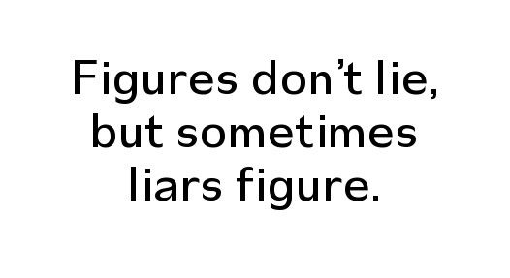

Dear Management: It's often said that numbers don't lie, people do!  
  
But I don't think that's completely correct.  
  
I see plenty of numbers and statistics that... while maybe not outright lying... severely bend the interpretation of the outcome.  
  
For example...  
  
How many new proposals for (insert here), have you seen... and the rosey glasses worn the creator(s) of the numbers, are so solidly rosey... you can't even see through them.  
  
It happens, and well... so be it.  
  
For the real lesson of today's tip... is to REALIZE that there can be a biased slant present...  
  
And to DISCOUNT for it... or at a minimum, make the creator(s) provide the assumptions baked in.  
  
THAT is the only way to interpret the true story... the numbers are trying to tell you.