(Mr. Tenkey's Tips # 355) www.mrtenkey.com

July 20, 2020

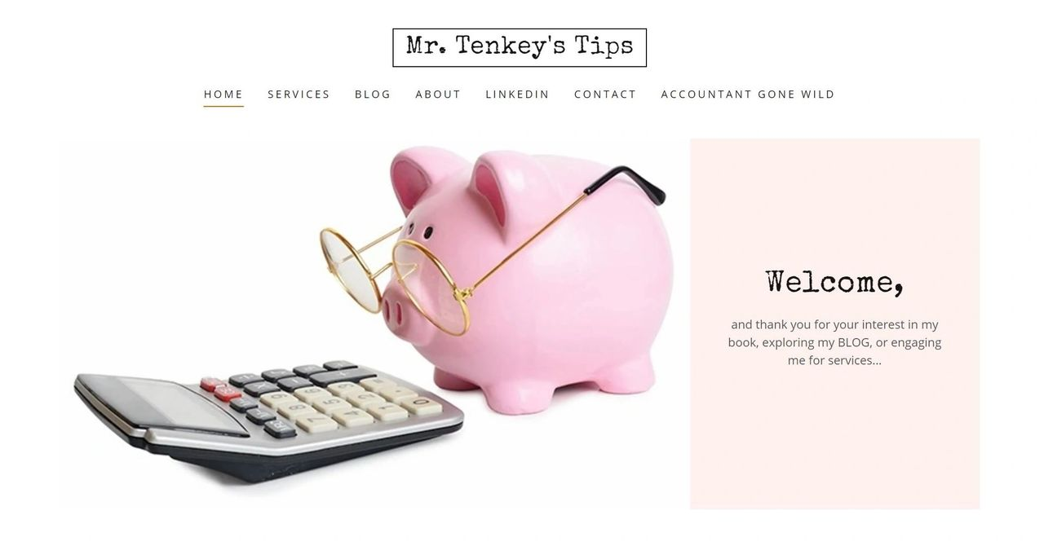

Dear Management: Why limit my professional interactions with the outside world... to writing a book or this blog?  
  
I mean, why not continue to set off sparks... and go to the people...  
  
Through conversations and limited scope engagements.  
  
Consultations can range from simple conversations and advice sessions over the phone or video... to process (setup, advice and/or design concepts)... to limited on-site visits.  
  
Further details available on my website.  
  
Yours Truly,  
Mr. Tenkey

**Share this post:**