Mr. Tenkey's Tips # 356) www.mrtenkey.com

July 21, 2020

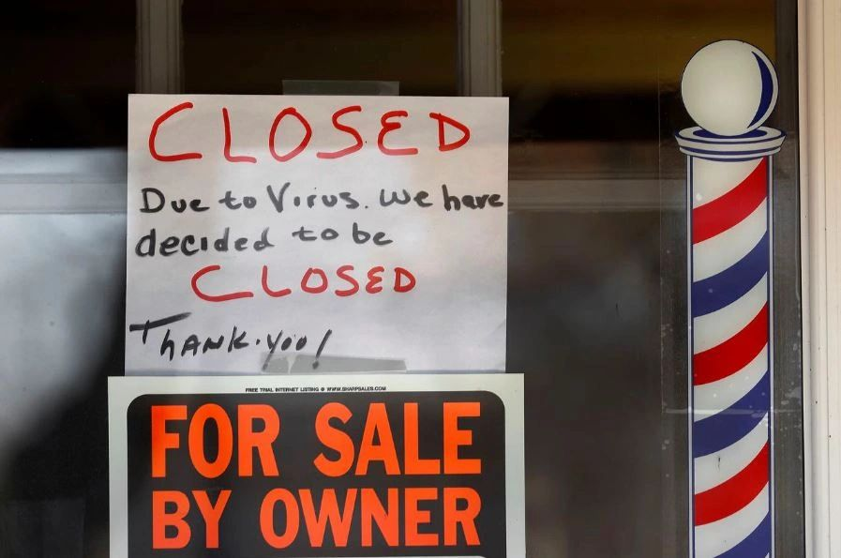

Dear Management: FYI - Due to the pandemic, small business bankruptcies are on a projected steep incline now... through the coming year.  
  
Why do you care?  
  
Well first... you just should... because it's terrible the loss of a unique character in our neighborhoods.  
  
And second... because it could possibly have an effect to your bottom line.  
  
Think about it... we're in an "out of this world" refi boom. Can you not think that a portion of those loans, YOUR company is doing... are with employees and owners of those self-employed small businesses... with a possible bankruptcy looming???  
  
Are you even looking at the industry of the income used to underwrite those loans... and factoring for that?  
  
I might suggest a double look at income generated from restaurants/bars, wedding planners, barber shops, movie theaters, concert halls, etc.  
  
Just sayin.