(Mr. Tenkey's Tips # 358) www.mrtenkey.com

July 23, 2020

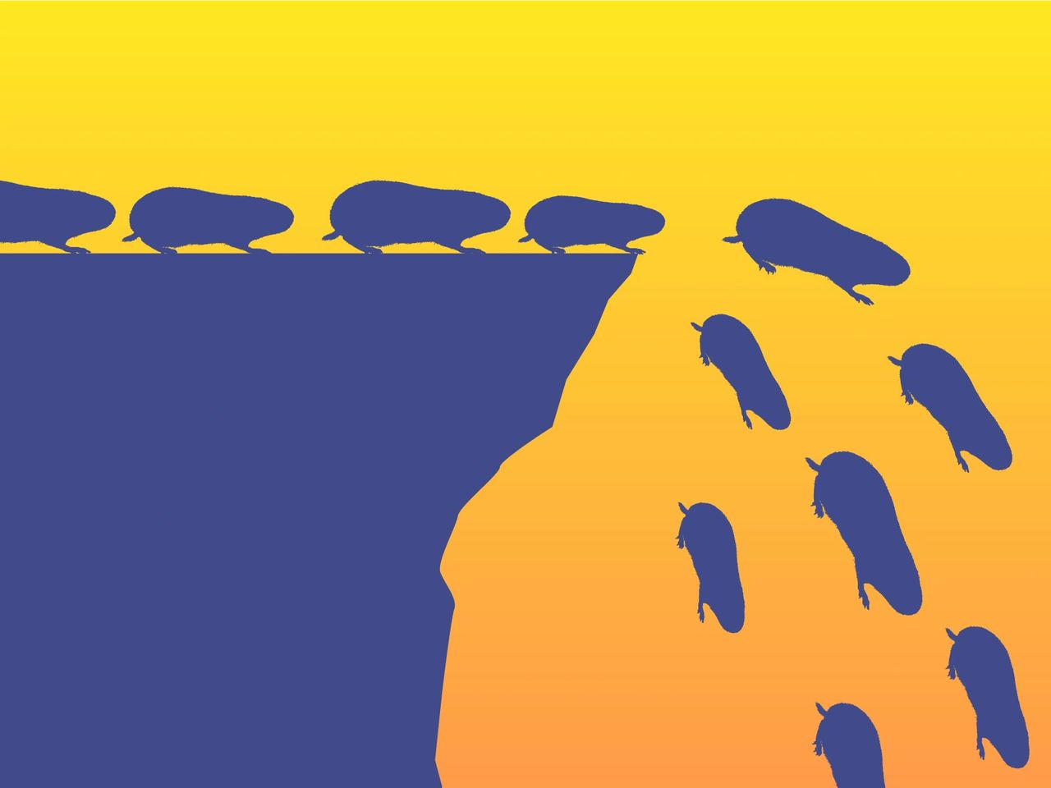

Dear Management: When co-workers are chatting and they come to the same conclusion...  
  
They often spout, "Ha... great minds think alike."  
  
But beyond the funny nature of that... I say PHOOEY!  
  
Because with great minds thinking the same... often comes with the UN-GREAT side effect of group-think.  
  
And that is TERRIBLE for an organization.  
  
Because great groups and organizations actually THINK DIFFERENTLY.  
  
And that is a good thing!  
  
You WANT challenges to the norms... of how things are thought that they should be done.  
  
You WANT people to approach business decisions from different lines of thoughts.  
  
You WANT... diversity in opinions  
  
Otherwise, an organization ends up as lemmings... following the most charismatic member...  
  
Where-ever that leads.