(Mr. Tenkey's Tips # 372) www.mrtenkey.com

August 12, 2020

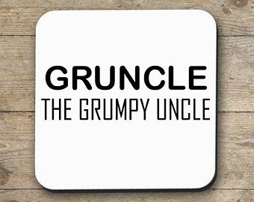

Dear Management: Contrary to popular belief!  
  
Being contrary to someone's "GREAT" idea... is NOT being negative...  
  
When your explicit job is to evaluate "GREAT" ideas... that are...  
  
FYI... NOT-so-great.  
  
I often get called "grumpy uncle", as this scenario plays out...  
  
BUT I'm also, not often... off the mark.  
  
Contrary to popular belief!