(Mr. Tenkey's Tips # 375) www.mrtenkey.com

August 17, 2020

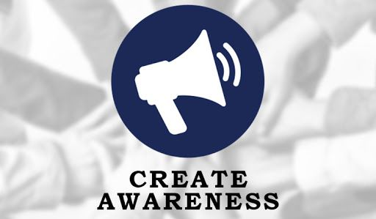

Dear Management: A BIG part of marketing a Company and it's LO's to the world at large...  
  
Is creating AWARENESS!!!  
  
The whole, planting a flag and yelling out "I AM HERE" to the world of potential borrowers.  
  
And the secret to awareness is to create it at ALL stages of the borrower's needs cycle.  
  
What does that mean?  
  
Plain and simple...  
  
Help your potential borrowers... at the various points WHEN they: Want to know (information)... or go, do, and buy/refi (take various actions).  
  
Create campaigns that pin-point the needs of the borrowers at the different stages of the "needs" life cycle...  
  
And show them how your LO or your Company is gonna fill those needs.  
  
My couple pennies.