(Mr. Tenkey's Tips # 378) www.mrtenkey.com

August 20, 2020

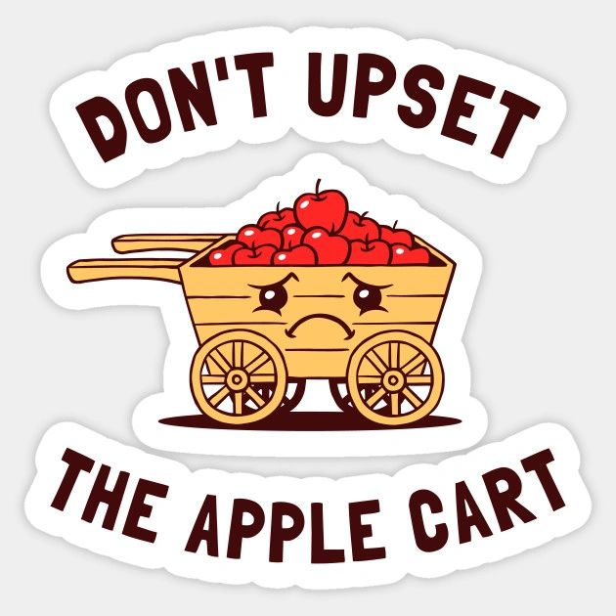

Dear Management:  Sometimes honesty upsets the apple cart.

But sometimes the apple cart NEEDS to be upset...

Allowing the apples spill all over the ground.

To THEN...

Be picked up, and put back in the cart... in a much more balanced fashion.

Yep, sometimes...