(Mr. Tenkey's Tips # 391) www.mrtenkey.com

September 9, 2020

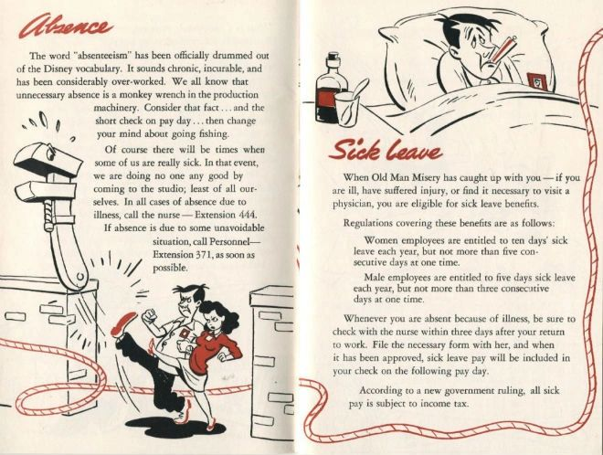

Dear Management: Where is your employee handbook?  
  
Don't know? Well you should...  
  
As it is a living document to quantify what your company is all about and memorialize the rules of the road.  
  
How can your employees have honor in your workplace... without a code for them to follow?  
  
And to be accountable to... the employee and the company, alike.  
  
Also, a couple other quick tips to be followed... once you do find it.  
  
- It should be online and accessible by ALL. No reason to kill a tree every time you update it.  
  
- It should be updated regularly... What do I mean by that? Anything on Covid in there? Then you ARE NOT updating it regularly.  
  
- Oh, and don't write in legal-eeze... If you can't understand it, neither will your employees.  
  
- And KISS it... (keep it simple stupid).  
  
That's good for now.  
  
Now go, get crackin'!