(Mr. Tenkey's Tips # 396) www.mrtenkey.com

September 16, 2020

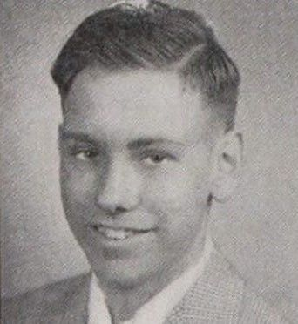

Dear Management: Headshots... they're not just for business cards anymore.  
  
That picture will HAUNT you everywhere your social fingerprint is placed... as your NEW first impression to the world.  
  
So a few things to remember:  
  
UPDATE it more often than not.  
  
For example, who would you rather get a loan with?  
  
The person I posted a pic of... then? or Warren Buffet now?  
Same person... just a different decade or seven...  
  
And don't get me started on the glamour shots era... ladies... and a few men too. You're not interviewing for a leading role in a D movie.  
  
Also... be careful of your background choices. When "it" is more interesting than you... that's not good peeps.  
  
And remember to not go cheap on photography. More pixels is NOT a bad thing, unless you're 55 and still trying to pass as 25.  
  
And lastly... please, please, please... practice your smiles. Looking constipated is not a crowd-pleaser.  
  
My couple pennies.