(Mr. Tenkey's Tips # 401) www.mrtenkey.com

September 23, 2020

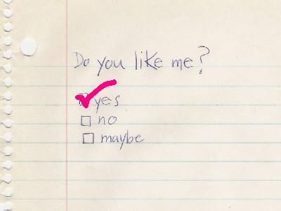

Dear Management: Relationships with co-workers... often mirror those in your personal life.  
  
And, just like those awkward rituals as a child...  
  
You know, the ones where you pass a note to see... "Do you like me? yes, no or maybe?"...  
  
It all just becomes a part of standard life experiences, that we all go through.  
  
BUT, one lesson stands true through it all...  
  
How YOU break up with someone, says MORE about your maturity...  
  
Then how well you may have won them over for the first date.  
  
Wanna know if you've learned that lesson?  
  
The exam: A co-worker is leaving your company.  
The test: Your reaction.