(Mr. Tenkey's Tips # 403) www.mrtenkey.com

September 25, 2020

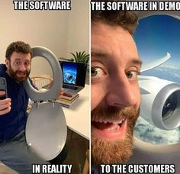

Dear Management: Who's tired of software...  
  
That completely DOESN'T live up to the hype that is expressed in the demo?  
  
Me too!  
  
Don't they understand...  
  
A software that is truthful of it's capabilities and betters itself with experience...  
  
That's the one I'd pick every day.