(Mr. Tenkey's Tips # 405) www.mrtenkey.com

September 29, 2020

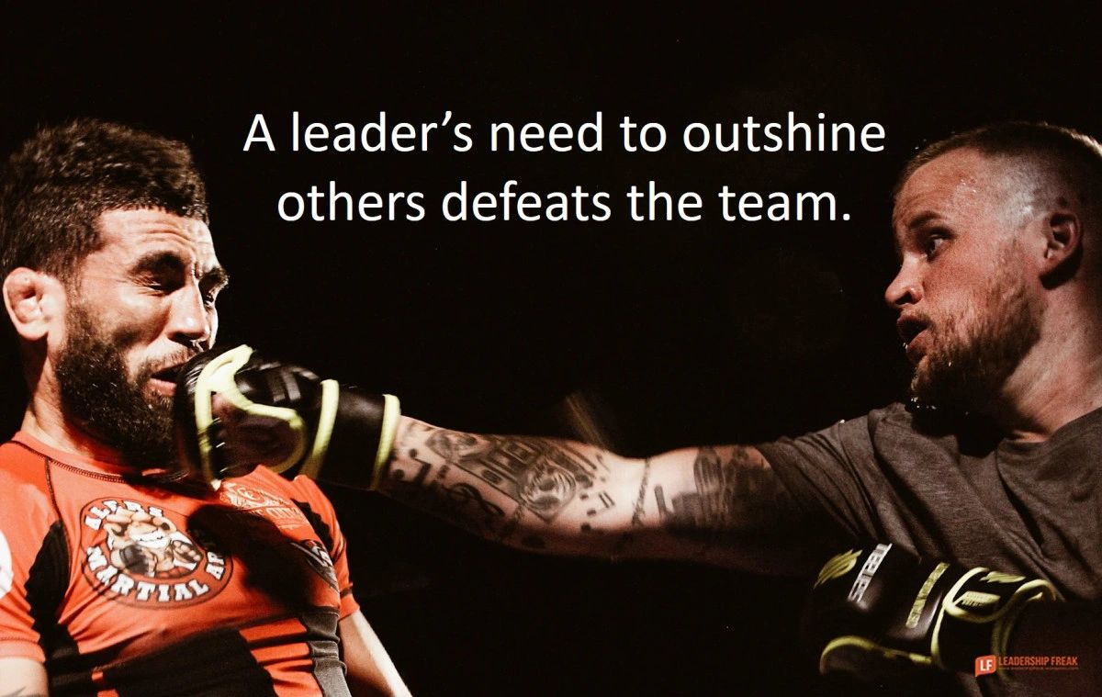

Dear Management: One thing often recited from a poor leader...  
  
"If I'm wanting to get it done right... I'll just, have to do it myself."  
  
First, that ego... you'll be needing to let go of that. That's if you're wanting your dept/division/company's growth... to move beyond your own personal abilities.  
  
Second, SLOW DOWN. Leadership is more than just BARKING commands...  
  
You must also TEACH, the skills and reasoning... behind each command. And be open to LEARN that those commands may also... need to be bettered.  
  
Finally, there must be a realization that even though you might quip that your job would be easier, if it weren't for people... you wouldn't be here if not for them.  
  
Sidenote - Figure out how to lead better, and you won't be nearly as mad at those people.  
  
My couple pennies...