(Mr. Tenkey's Tips # 411) www.mrtenkey.com

October 7, 2020

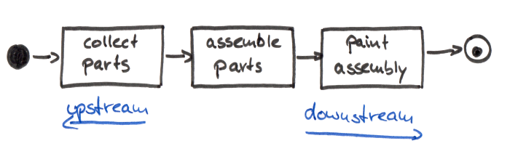

Dear Management: PICTURE IT... You and your cohorts have just "streamlined" a process performed by your department...  
  
You're all happy... high-5'in!!!, etc.  
  
But wait... a process upgrade for the company... it is NOT!  
  
As now, what was changed... (which was done in the vacuum of your department)... has had negative consequences on the other departments up and downstream from your own.  
  
Why? How?  
  
Cause no one called the parties that needed to be involved to a simple meeting to... "scenario it out."  
  
What can be done?  
  
Ugh... Talk to one another people!  
  
AND SCENE...