(Mr. Tenkey's Tips # 415) www.mrtenkey.com

October 13, 2020

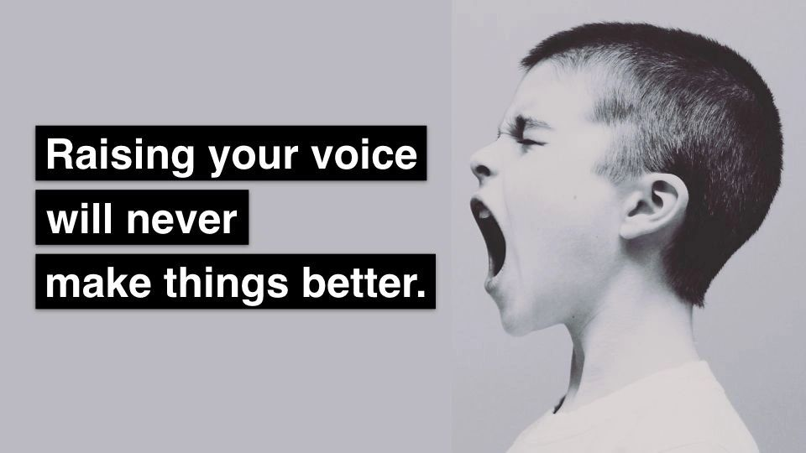

Dear Management: The raising of your voice...  
  
Does not RAISE the competency of your point.  
  
The puffing of your chest...  
  
Does not "POOF", make the underlying conflict go away.  
  
It ONLY... stifles forward movement.  
  
Evolve!  
  
Then move one foot after the other... forward...