(Mr. Tenkey's Tips # 416) www.mrtenkey.com

October 14, 2020

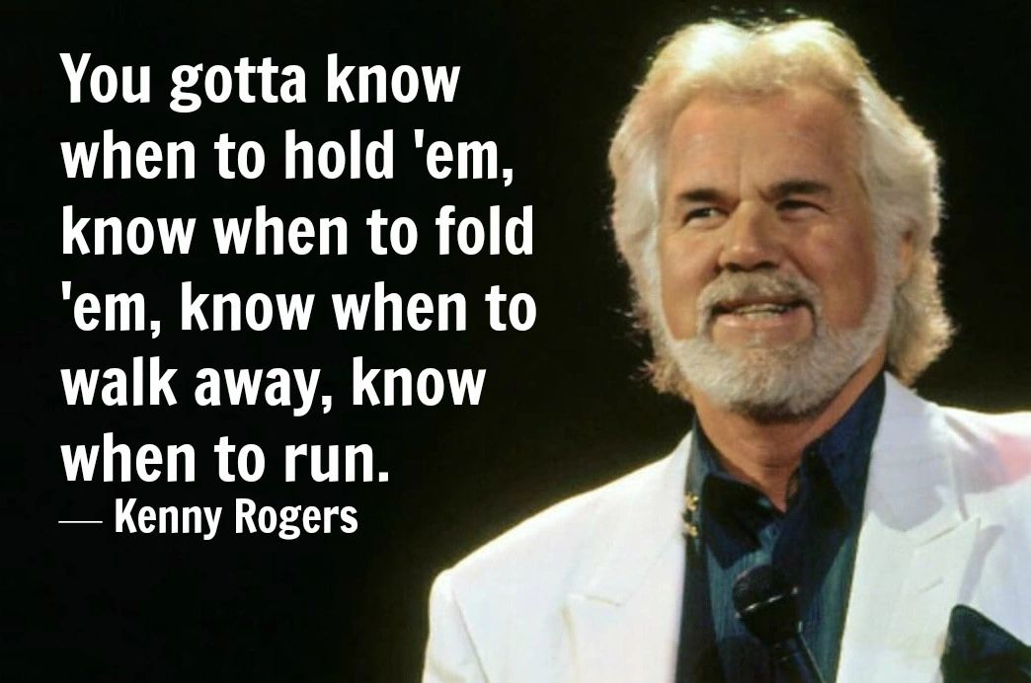

Dear Management: Salespeople are not programmed to give up.  
  
They are not programmed to walk away.  
  
So to be a good leader... to them, and the business you own or work for...  
  
You need to teach them WHEN to fold.  
  
You need to train them to separate a deal that's a difficult sale, from that transaction that's just a bad deal.  
  
The better job you do in training them on THAT!  
  
The better frontline defense you'll have, to the operational efficiency of your pipeline.  
  
FYI - Just channel Kenny, and you'll do fine!