(Mr. Tenkey's Tips # 417) www.mrtenkey.com

October 15, 2020

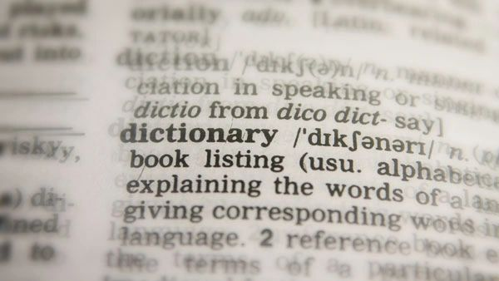

Dear Management: A dictionary is just a book... full of words... we all use to communicate.  
  
And just like in a dictionary...  
  
Each word we use, may have MANY definitions.  
  
So just because you use word "X"...  
  
Does not mean the listener hears meaning "Y"...  
  
And raising your voice... or s...p...e...a...k...i...n...ggggg slower is not the answer.  
  
CONTEXT is!  
  
So again, just like in a dictionary... use yours word in a sentence. Give examples of your end hope.  
  
Communication is about the connection of the intent...  
  
NOT the parsing of words.  
  
My couple pennies...