(Mr. Tenkey's Tips # 418) www.mrtenkey.com

October 16, 2020

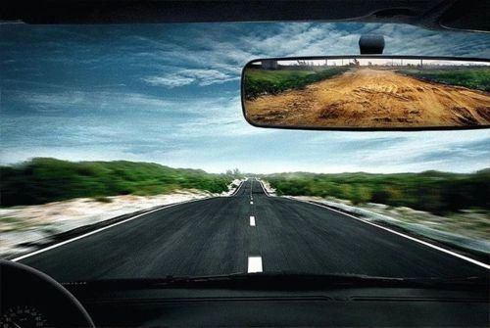

Dear Management: When the end of a job comes...  
  
Whether you were asked to leave or made that choice yourself.  
  
Do you want your rear view mirror to show some action that you "could of/should of" done?  
  
Or... of you holding true to what you believed the duty of your employment was?  
  
I myself, would choose the latter...  
  
And urge you, to do the same.  
  
Because, when the dust settles... you'll be able to live with the pride of your employment.  
  
And, your former employer?  
  
Well, they won't matter... so pay them no mind.