(Mr. Tenkey's Tips # 421) www.mrtenkey.com

October 21, 2020

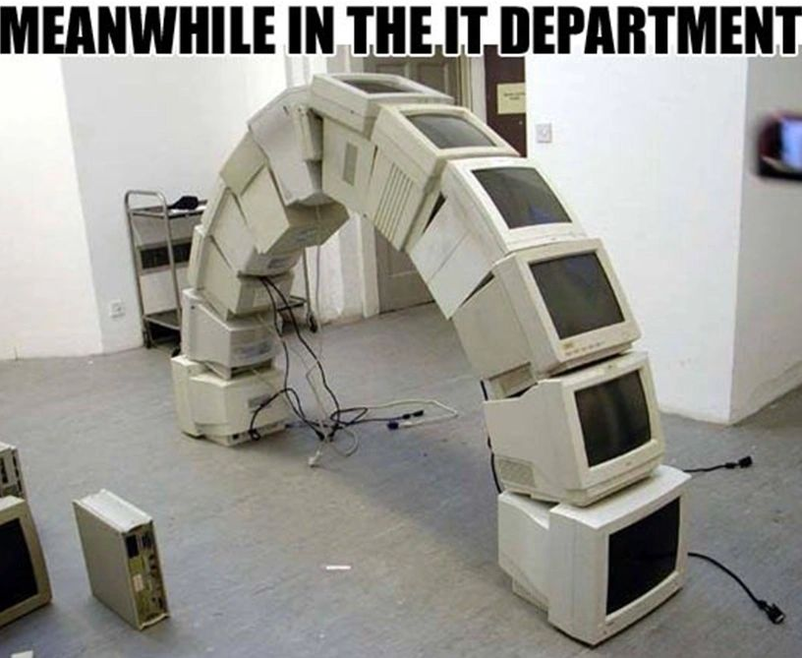

Dear Management: There's very few departments that are under attack MORE than your IT department... for the costs involved in running it.  
  
And even though so much of our current day to day life relies on solid technology... so OFTEN, little attention is paid to this dept.  
  
So to combat this persistent negative view... a company needs to find leadership within the dept that will move the perception of IT from being simply a cost center... to that of a business partner... with a strategic view.  
  
Yes, leadership that can move the dept from survival mode to an alignment with business advancement... in a proactive way.  
  
Do THAT... and your IT dept goes from under attack... to offensive moves.  
  
My couple pennies...