(Mr. Tenkey's Tips # 425) www.mrtenkey.com

October 27, 2020

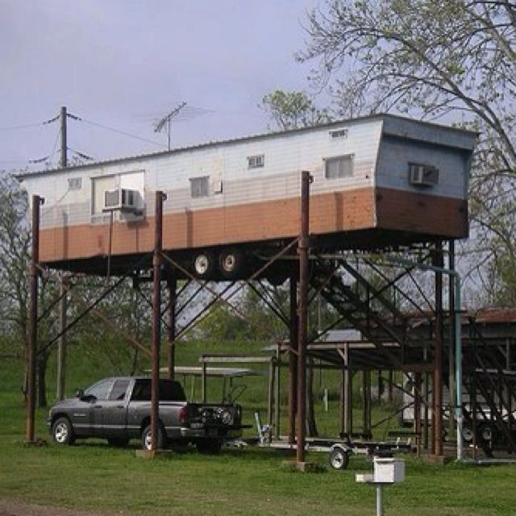

Dear Management: Will residents of Beverly Hills be filling their backyards up with manufactured homes soon?  
  
Well...  
  
Fannie Mae did JUST change its guidelines to allow qualified manufactured homes as ADU's... on the same property as a single family resident.  
  
Now, don't get too excited... you will still need to have comps in the area... so Beverly Hills is probably safe for now.  
  
In other locations however... this could help in the fight for more affordable housing options... as well as, helping house aging parents or other family members... (those kids that JUST WON'T MOVE OUT...)  
  
The devil IS in the guideline's details, but the subject matter gave me a chuckle... so had to post it.  
  
Now you know...