(Mr. Tenkey's Tips # 431) www.mrtenkey.com

November 4, 2020

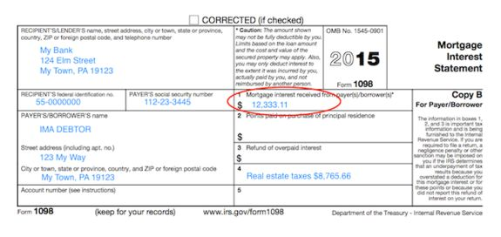

Dear Management: Is a home interest deduction better for the borrower... than having the loan paid off?  
  
Let me stop this right here...  
  
In all but a FEW SELECT situations, it is NOT better.  
  
I will give you this... yes, they MAY pay more in taxes... (that's the excuse you were gonna use right?)  
  
Well, what isn't being said is that statement... is... the "more" in taxes would be FAR LESS than the amount of interest being paid OUT monthly.  
  
And the net result IS WHAT matters!  
  
Because, THE ONLY way debt on a house is better... is if that borrowed money "earns" (the borrower decides this) more than the loan's carrying costs.  
  
Now... I get it... we're in the industry to LEND money.  
  
WELL... fortunately, not everyone is fortunate enough to be able to buy a house with cash.  
  
But EVERYONE CAN consume (and repay) debt in a thoughtful and knowledgeable way.  
  
And being a part of that honest conversation with your borrowers WILL win you the day.  
  
My couple pennies.