(Mr. Tenkey's Tips # 440) --- book available @ www.mrtenkey.com

November 17, 2020

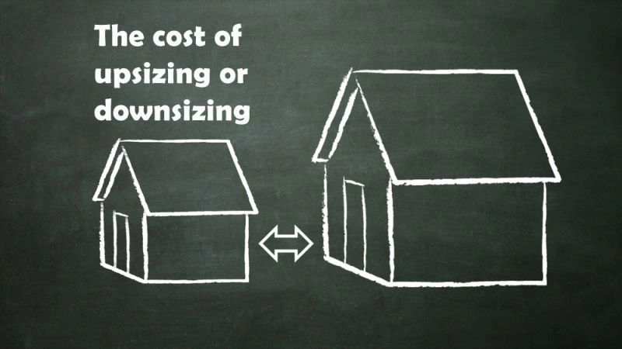

Dear Management: OK... So, you've had almost a year of this COVID (pardon my French)... crap!  
  
But, vaccines are looking promising, lights are appearing at the end of the tunnel, etc...  
  
What are your plans long term for employees and spacing needs?  
  
Who's coming back, who's staying remote, who will be both??? What are your spacing needs? Downsizing? Growing?  
  
What leases are being renewed? Which are going away?  
  
What questions are you asking? What scenarios are you processing through?  
  
Nothing? NO PLAN?  
  
That is SAD peeps...  
  
Change that.