(Mr. Tenkey's Tips # 445) --- book available @ www.mrtenkey.com

November 24, 2020

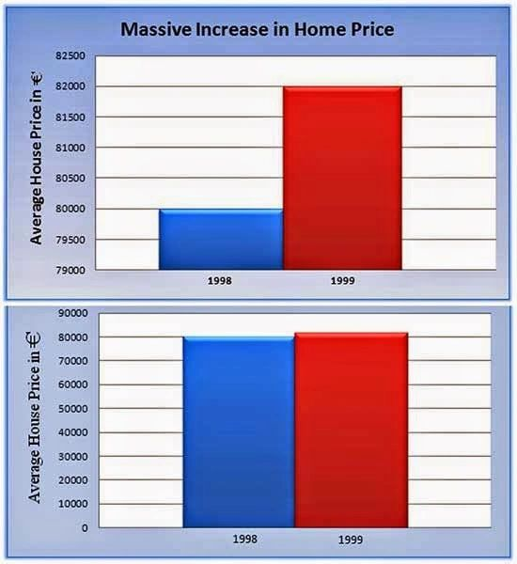

Dear Management: When you're provided graphs/ratios on "important" matters...  
  
That demand an "important" response/decision.  
  
PLEASE ask for supporting data.  
  
Because what may sound very bad or very good... isn't always what is displayed.  
  
(for example): "We just had a 100% increase in defaulted loans, in our last qtr over qtr analysis..."  
  
This isn't so bad... when you discover you only had 2 loans last qtr and 1 loan the qtr before that... out of 10,000 loans funded.  
  
Versus, all you funded were 3 loans in those past two qtrs... then that is a different story.  
  
So my point?  
  
CONTEXT MATTERS!  
  
Make sure the people providing you information understand that fact and present the data FAIRLY!