(Mr. Tenkey's Tips # 449) --- book available @ www.mrtenkey.com

December 2, 2020

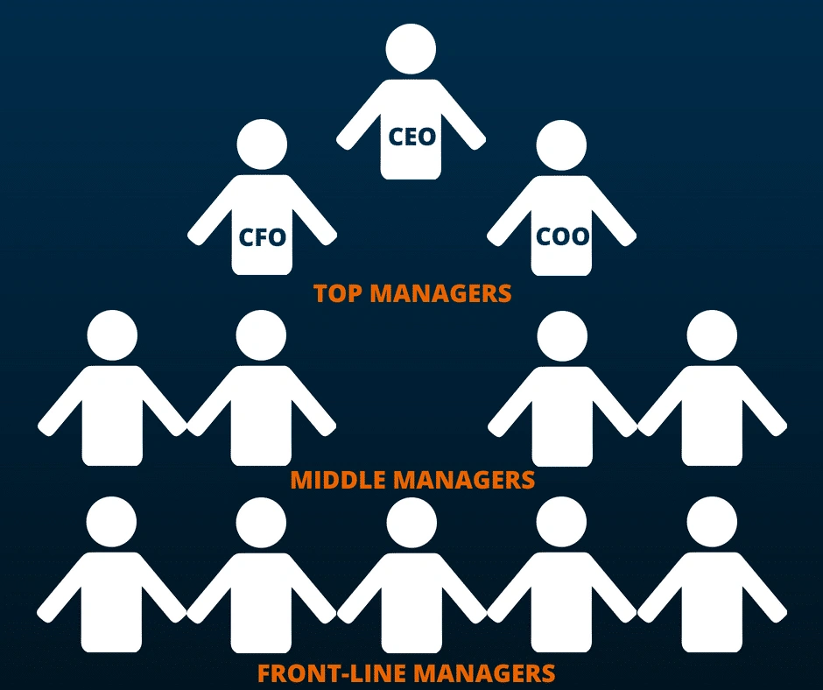

Dear Management: Questions are raised...  
  
"Why will none of the employees go to their managers for answers... Why do I have to answer everything???"  
  
Contemplation time:  
  
1) Are your employees inept? Can they just not remember who their managers are?  
  
2) Are your managers inept? Do they just not know the answers?  
  
OR...  
  
3) Are YOU not reinforcing your own company's mgmt hierarchy?  
  
Which includes... properly training mgmt the way you want things done and pushing back on employees to go through the chain of command.  
  
Because... NO employee is gonna waste their time going to a manager... that they know has no power to stand behind what answer(s) they give.  
  
Which in the end... just hurts YOU.  
  
In... the over-burdening on YOUR time... inefficient usage of mgmt resources that YOU'RE paying for... and the lack of growth beyond YOUR capabilities...  
  
My couple pennies...