(Mr. Tenkey's Tips # 450) --- book available @ www.mrtenkey.com

December 3, 2020

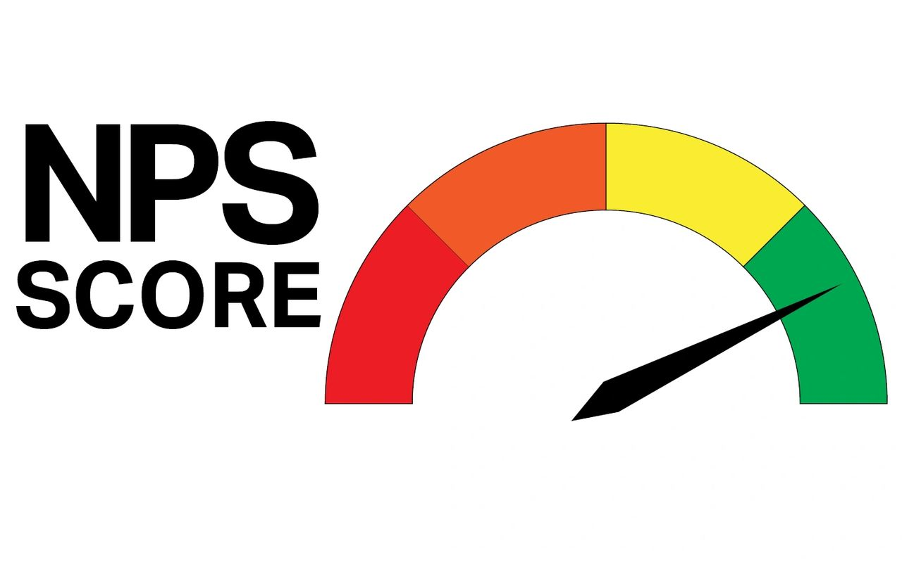

Dear Management: What is your NPS?  
  
Don't know what that is? Well you should!  
  
It's your Net Promoter Score, and it will change the way you look at borrower feedback.  
  
The calculation can be google'd for more details... I just did.  
  
And it will reshape the way you will look and track your borrower's experience from here on out.  
  
So go calculate it and see where you fall.  
  
Generally speaking:  
  
(100) to >0 = Needs improvement  
0 to 30 = Good  
31 to 70 = Great  
71 to 100 = Excellent  
  
SO? How well are you doing? As compared to your industry's standards?  
  
Good luck!