(Mr. Tenkey's Tips # 451) --- book available @ www.mrtenkey.com

December 4, 2020

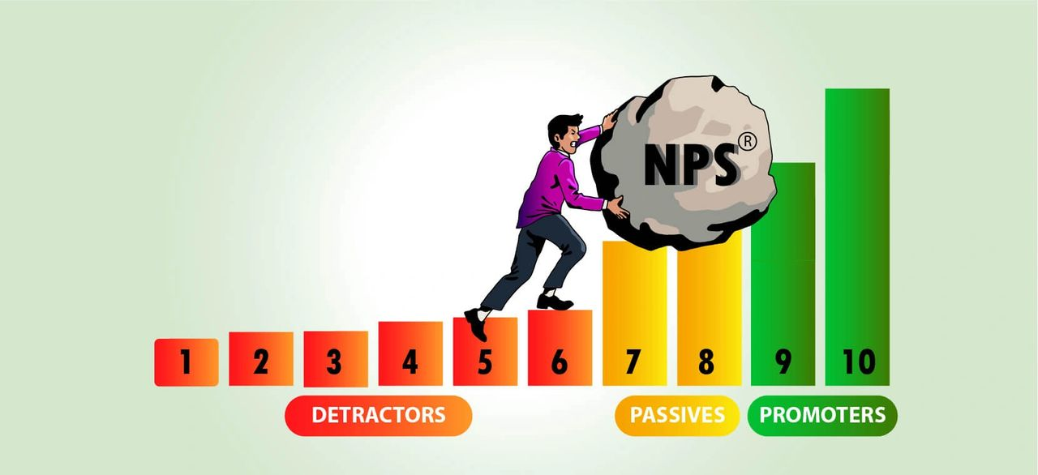

Dear Management: Just as important as "What is your NPS?" (prior post)... is the question, "How has it changed"?  
  
Because great... your score was "X", when you calculated it 4 mths ago...  
  
But now it's "X" - 10.  
  
That's worth looking into...  
  
What is happening? Why?  
  
Your brand is on the line people!  
  
How MORE important does it need to get?  
  
And, isn't it great you have this tool?  
  
Just sayin'