(Mr. Tenkey's Tips # 459) --- book available @ www.mrtenkey.com

December 16, 2020

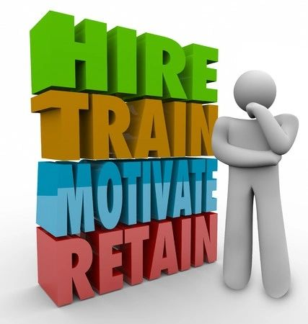

Dear Management: Perpetually training new employees is costly and time consuming.  
  
So hire leadership that can do the job correctly. People that can train effectively... and bring out the best habits in an employee.  
  
Or... a BIG DRAIN on resources, it will become.  
  
And by drain... I mean you go through all that trouble and expense to train them your way... to only have them leave and go your competitor's way.  
  
BUT rest assured... if you see that your employees ARE being trained well and properly motivated...  
  
You've hired the proper leadership team that will retain them too.  
  
Because employees stay where they are valued as a person, and becoming more valuable as a worker.  
  
Just sayin.