(Mr. Tenkey's Tips # 465) --- book available @ www.mrtenkey.com

December 29, 2020

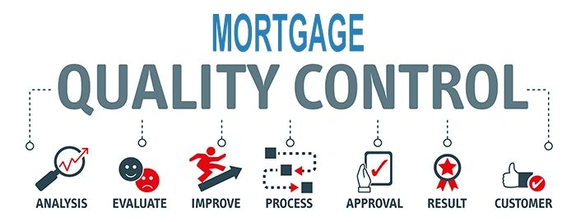

Dear Management: It has been the best year for the mortgage industry, in YEARS!  
  
But now, it's starting to trail downward...  
  
And time to look behind you a little.  
  
Did your loan quality stay strong? diligent? compliant?  
  
Hopefully none of those answers were "no"...  
  
Because as they say,  
  
"All bad loans... were made during good times."  
  
And extended good times, make the loan origination process sloppy...  
  
Have you been monitoring that?  
  
Just sayin'