(Mr. Tenkey's Tips # 466) --- book available @ www.mrtenkey.com

December 30, 2020

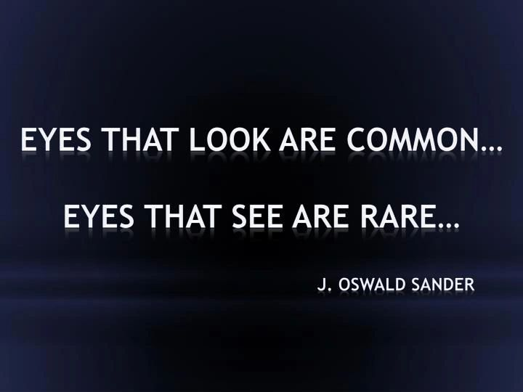

Dear Management: It's year end employee evaluation time for a lot of companies out there.  
  
And first, I must say, this is not a great thing by my standards... as you should have been giving feedback all year long... good, as well as constructive.  
  
But such is life... not everyone heeds my warnings.  
  
And not everyone dives below the surface of appearance, when evaluating their employees.  
  
- As they look at the 70 hrs of work/per week a person is putting into a job... as great!  
- As they look at all the LO's being brought into the company by a certain sales person... as great!  
- As they remember all the times an employee agreed with their ideas during the year... as great!  
  
- But don't see that the 70 hr person could have done the same job efficiently in 30...  
- But don't see that the LO's being brought in are eating up valuable company operation's time and producing at levels 1/3 of expectations.  
- But don't see that the ideas that were agreed to, should have been modified or been told to be scrapped.  
  
So dive below the surface people...  
  
Or you'll only see and hear...  
  
What you want to...  
  
Not what you need to.