(Mr. Tenkey's Tips # 470) --- book available @ www.mrtenkey.com

January 6, 2021

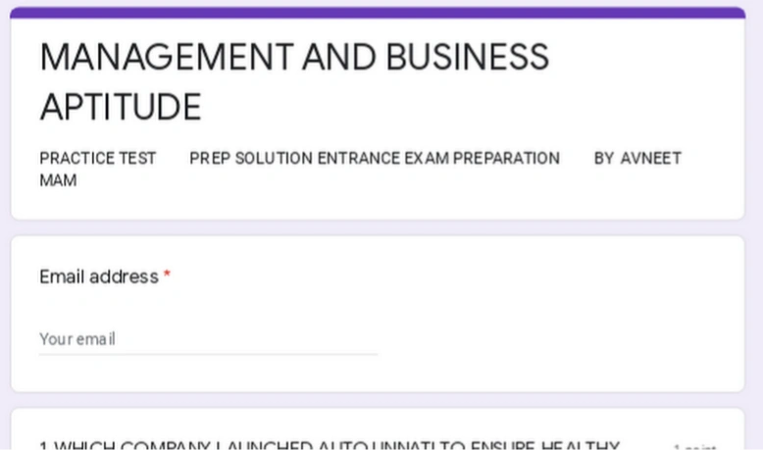

Dear Management:  Let's test that business aptitude, that I mentioned in yesterday's post.

So...

What if I said, that because of YOUR actions (or lack there of), during this so-named "anomaly" year...

You left 1/3rd more, of your resulting net income on the table.

And then... I told you that with some moderate moves, you could have "out performed" the market, instead of just be handed what the market gave you?

As out performance, is the real test of business aptitude...

Just because you made money, doesn't mean you performed well.

Especially, if YOUR same actions... in a bad year, would of lost you money.

Just sayin'