(Mr. Tenkey's Tips # 478) --- book available @ www.mrtenkey.com

January 18, 2021

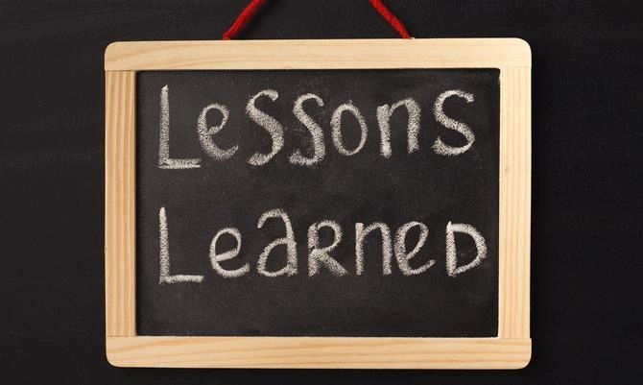

Dear Management: "Chalk it up to a lesson learned"... is another... BETTER way to say... "You failed!".  
  
As it's constructive... NOT destructive, to the person hearing those words.  
  
So... as a leader, if you berate people under your command for "Failing!" a task.  
  
The only person that truly fails, is YOU... in not making it a learning moment.  
  
Because, instead... the only lesson learned...  
  
Is that you're a donkey.  
  
And, we all know another... better way to say donkey.