(Mr. Tenkey's Tips # 480) --- book available @ www.mrtenkey.com

January 20, 2021

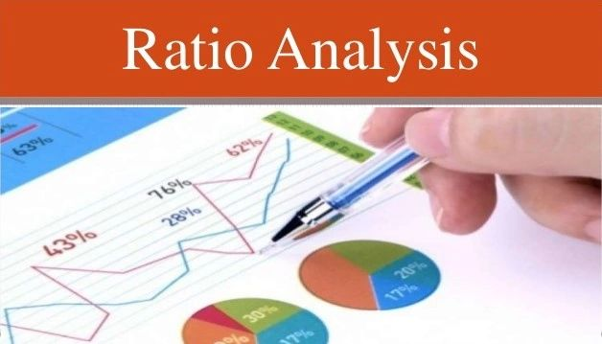

Dear Management: The best graph... the best ratio... the best whatever...  
  
DOES NOT replace simple knowledge of the underlying data points, industry performance or real life work experience... that all leaders/managers in your company should possess.  
  
So be careful of throwing those new fangled ratios at your leaders/managers... before, they have the understanding of how to question the results.  
  
(Hint: a positive number or an upward trend is not always a good thing.)  
  
But if they don't understand the underlying data points, they'll never know that.  
  
Instead, try starting with making sure they understand how the pieces were created, before you ask them to put the puzzle together.  
  
Otherwise you'll have leaders/managers that just look at the bottom line for a positive number...  
  
Rather than whether that performance was acceptable or not... based on the relevant criteria.