(Mr. Tenkey's Tips # 483) --- book available @ www.mrtenkey.com

January 25, 2021

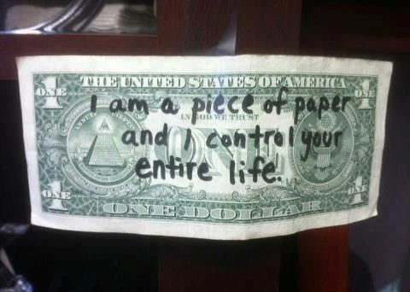

Dear Management: Don't let anyone fool you... money, does make the world go round.  
  
But how much of it do YOU need?... and WHAT will you do (and not do) to possess the "right" amount?  
  
Too often, a sad cycle follows that sentence...  
  
So be mindful of who you're around, as your world turns toward the sun.  
  
There might not be a pot of gold, at the end of that rainbow.  
  
And hey, I too have fallen victim from time to time...  
  
But with age has come wisdom.  
  
And my biggest takeaway...  
  
Money only amplifies the personality of the person who possesses it.  
  
So, if you're a decent person before money, you'll be a better person after.  
  
And if you're not... well, I've learned... I need to move beyond those people.  
  
Hopefully now, you will too.