(Mr. Tenkey's Tips # 489) --- book available @ www.mrtenkey.com

February 2, 2021

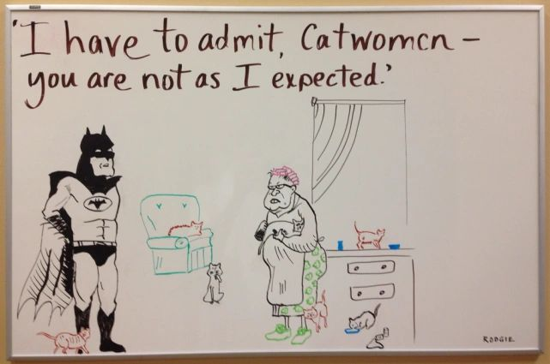

Dear Management: The BEST tool I have ever found to communicate an idea to another person...  
  
Is... TAH-DAH! A white board.  
  
In my view, there is NO BETTER way to work out ideas between two or more people...  
  
Or between you and your own thoughts for that matter.  
  
Right there, on the spot and dynamic.  
  
Simply put... a white board lets you visually translate, what's in your head to another person's eyes.  
  
Now, excuse me while I go buy stock in a white board factory.  
  
I feel a surge in demand coming, after this post.