(Mr. Tenkey's Tips # 492) --- book available @ www.mrtenkey.com

February 5, 2021

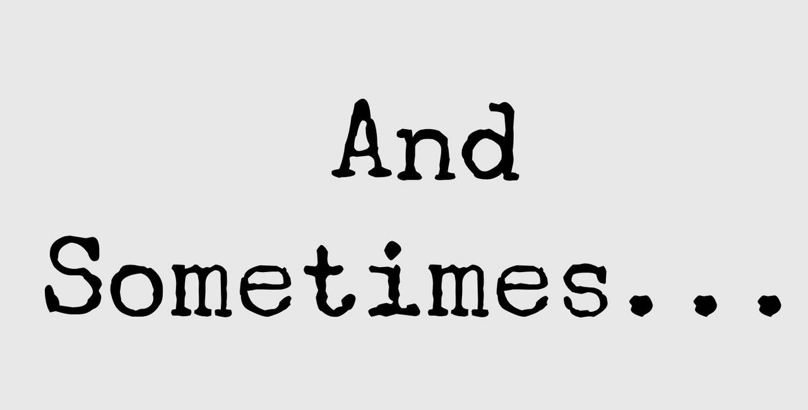

Dear Management:  Sometimes...  
  
Sometimes... your good efforts seem pointless.  
Sometimes... those efforts don't lead to the outcome you had hoped for.  
Yep, sometimes... the stars just don't align.  
  
Sometimes... a separation is needed.  
Sometimes... those efforts need to be focused elsewhere.  
Yep, sometimes... a farewell is best.  
  
Sometimes...

(A soliloquy of a former employee, in F minor)