(Mr. Tenkey's Tips # 494) --- book available @ www.mrtenkey.com

February 10, 2021

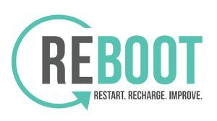

Dear Management: The best advice I ever received from my favorite IT person was...  
  
"Just REBOOT Chris.... yes, at the end of the day... reboot your computer as you log off."  
  
"Why? I asked..."  
  
And their response... "Because rebooting your computer..."  
  
-Helps keep computer cobwebs from forming.  
-Flushes your memory and stops all those latent tasks from dancing around in the background.  
-Is one of the easiest ways to fix connection problems.  
-Will speed up general system performance.  
  
  
So, I've done this over the years... and it's worked!... go figure.  
  
  
But now, lately...  
  
I've come to see that this reboot theory can work in other parts of your work life.  
  
To remove the cobwebs from a stale job, fix connection problems with co-workers/bosses, or to flush the memory all together... lol.  
  
Yes... whether that be a new group of co-workers, a new position, a new employer, whatever...  
  
As my favorite IT person once said... "Just reboot Chris, that'll fix everything!"