(Mr. Tenkey's Tips # 495) --- book available @ www.mrtenkey.com

February 10, 2021

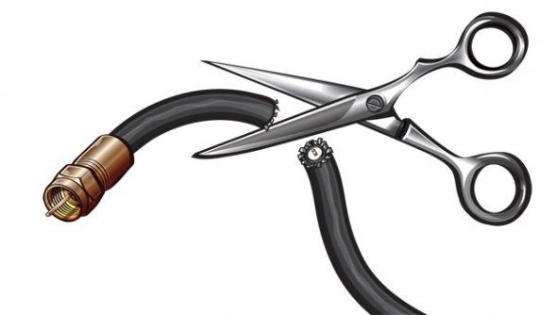

Dear Management: Do you treat your customers like (my cable company)?  
  
You know... where you only help the people that AREN'T your current customers?  
  
Focusing on getting new ones... giving THEM all the best deals...  
  
NEVER calling your current ones to better their plans...  
  
UNTIL they call complaining about cost and THEN and ONLY THEN do you tell them about a cost savings option?  
  
  
Am I bitter ? Yes  
Am I a (my cable company) customer? Not for long  
  
  
Hint - Your current customers got you where you are. Their loyalty is not your entitlement... It's only in trade for YOUR service to them.  
  
DON'T BE (my cable company)...