(Mr. Tenkey's Tips # 498) --- book available @ www.mrtenkey.com

February 16, 2021

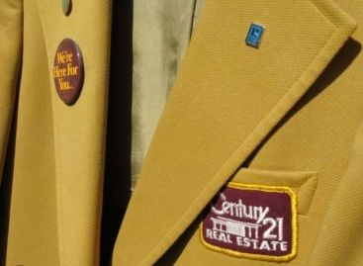

Dear Management: I don't think "the making of a loan officer" is a one size fits all thing... like a suit coat, that can be just slipped on.  
  
Even Century 21 had to buy different jacket styles and sizes, for their various realtors across the land.  
  
So why do so many companies think that a one size "X factor" is going to make their loan officers the "BEST!"  
  
Be it that ONE training certification, that ONE motivational speaker, that ONE "talking to", that ONE ???  
  
Loan officers are individuals... unique and varied.  
  
The real "MAKING OF" that companies need to work on...  
  
Is obtaining and retaining... strong leaders that find the unique keys, that unlock the potential...  
  
Of ALL their loan officers... in ALL the varied ways it takes.  
  
My couple pennies...