(Mr. Tenkey's Tips # 500) --- book available @ www.mrtenkey.com

February 18, 2021

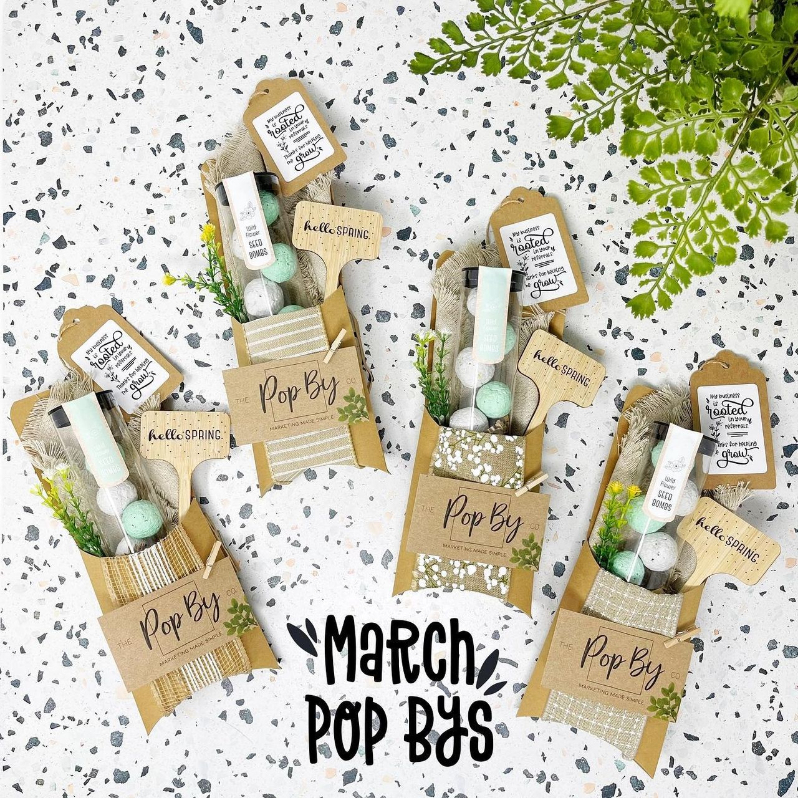

Dear Management: I was browsing down a marketing rabbit hole last night and landed on some cool Pop-By gift ideas (one of my favorites - attached).  
  
And, while some were NOT so innovative as advertised... (I mean, I've seen these things in one color or another for the past 20 years).  
  
Some did catch my eye...  
  
And the more I scanned, the ones that grabbed me the most...  
  
Were NOT the stale logo'd pens, key chains, mugs, mouse pads, etc.  
  
But the simple, yet creative ones... that provoke a good feeling.  
  
And I think THAT is the trick to these things... to create a moment.  
  
So...  
  
Have them remember you for the FEELING a marketing item gives...  
  
And not because your LOGO/COMPANY NAME is shoved in front of their face...  
  
As those just end up on the shelves at goodwill...  
  
And that's no good for anyone.