(Mr. Tenkey's Tips # 508)

March 2, 2021

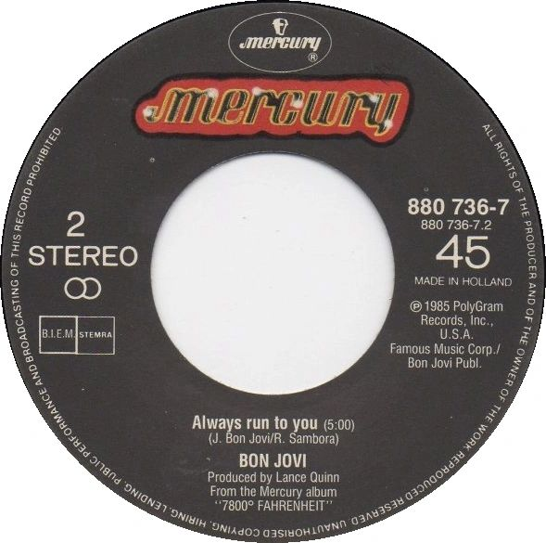

Dear Management: Cop in the bushes? or... Cop on the corner?  
  
As a leader... you choose how to patrol your beat.  
  
But remember, the civilians have a choice too.  
  
Run to you... or FROM you.  
  
So, will you:  
  
1 - Stand on the street corner, setting an example... sharing the rules of the road... helping pedestrians across the street... explaining errors as you see them... creating detours, so future mishaps no longer occur.  
  
or  
  
2 - Hide in the bushes and JUMP OUT! and capture people mid-error or mid, mis-understanding... handcuff, convict and vilify. All to make sure they NEVER DO THAT AGAIN!  
  
  
One is uplifting, forward moving, empowering, etc.... the other, well... just isn't.  
  
  
From my point of view... (and I've worked in both neighborhoods)...  
  
I choose to invoke the immortal words of Bon Jovi...  
  
Number 1... I will "Always run to you!"  
  
;) There's your ear worm for the day...  
  
You're welcome.  
  
(More blog posts or buying my book @ www.mrtenkey.com)