(Mr. Tenkey's Tips # 515)

March 11, 2021

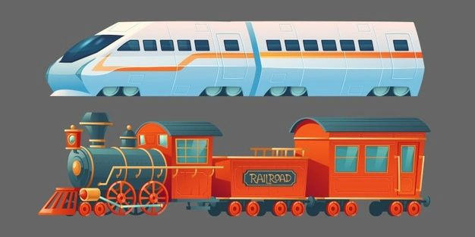

Dear Management: Situation - Two trains of thought...  
  
About what? - Staying in a job that you are (being nice here)... not excited about.  
  
  
Old train - "You don't want a blemish on your resume."  
New train - "Never be afraid to say you've tried something and it didn't work out, and why."  
  
Old train - "You might be leaving the frying pan... for the fire."  
New Train - "Or, now you know what to look for in your next place of employment."  
  
Old train - "You must be loyal to your employer. They gave you a job."  
New train - "Loyalty is not given to an employer, simply because they hired you. You work, they pay you... that's simply a contract. Loyalty is not a contract, it is earned as reciprocated."  
  
Old train - "Tough it out, rub dirt in it, walk it off... everyone hates their job."  
New Train - "No... no they don't. Life is too short to be unhappy in a job that takes up such a large part of it."  
  
  
All this is obviously done with a touch of humor... but in the end, it really comes down to the simple fact that not all relationships last.  
  
And as an employee... sometimes a revolving door... is the only type of door you have to choose from.  
  
It happens... move forward.  
  
And hey.... it IS ok.  
  
(More blog posts or buying my book @ www.mrtenkey.com)