(Mr. Tenkey's Tips # 516)

March 12, 2021

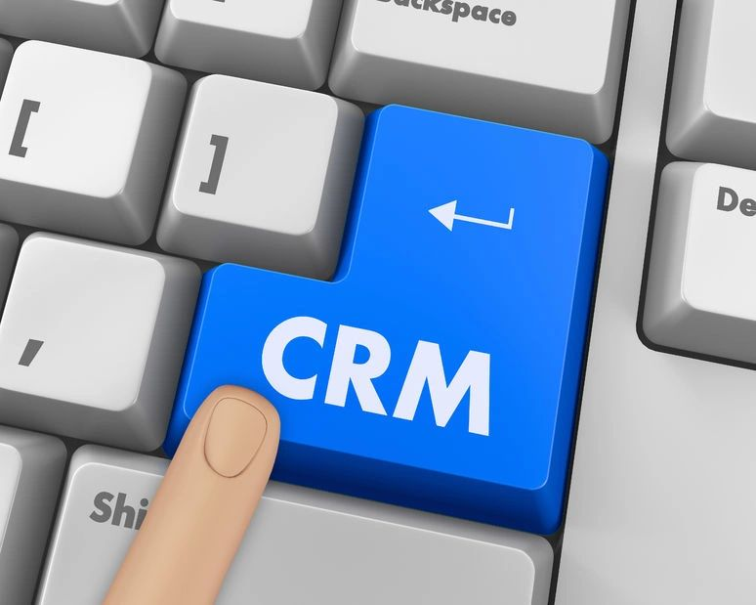

Dear Management: Here's an idea for getting LO's on board... when presenting a new CRM (client relationship management) software program.  
  
First, STOP!... showing them how to work within the program.  
  
Let's be real... most of the high volume LO's... the ones that you are buying this fancy software for... the ones that will get the biggest pickup from...  
  
ARE NOT going to be the ones data entering and data updating.  
  
It will be their assistants.  
  
You'll lose them at... "Let's log in..."  
  
BUT... what you will need to do with these LO's... is get their buy in.  
  
Yes, you'll need them to be excited... so that they will allow their assistants to work on something, they deem to be a fruitful adventure.  
  
So, you want to win them over?  
  
Stop showing them the ins and outs of the software itself, and instead... focus on the results of what this software will do for them and more importantly...THEIR PRODUCTION.  
  
Show them 3-5 "real life" examples of how THEIR PRODUCTION will be positively affected.  
  
And BOOM!  
  
BUY IN!  
  
Otherwise... you should NOT be buyin' that software.  
  
(More blog posts or buying my book @ www.mrtenkey.com)